end;

var

Form3: TForm3;

implementation

uses Unit1, Unit4;

{$R *.dfm}

procedure TForm3.Image3Click(Sender: TObject);

begin

form3.Hide;

form1.show;

end;

procedure TForm3.Image4Click(Sender: TObject);

begin

form3.Hide;

form4.show;

end;

procedure TForm3.RadioButton1Click(Sender: TObject);

begin

showmessage ('SALAH');

end;

procedure TForm3.RadioButton2Click(Sender: TObject);

begin

showmessage ('SALAH');

end;

procedure TForm3.RadioButton3Click(Sender: TObject);

begin

showmessage ('SALAH');

end;

procedure TForm3.RadioButton4Click(Sender: TObject);

begin

{ Private declarations }

public

{ Public declarations }

end;

var

Form4: TForm4;

implementation

uses Unit1, Unit5;

{$R *.dfm}

procedure TForm4.Image2Click(Sender: TObject);

begin

form4.Hide;

form1.show;

end;

procedure TForm4.Image3Click(Sender: TObject);

begin

form4.Hide;

form5.show;

end;

procedure TForm4.RadioButton3Click(Sender: TObject);

begin

MessageDlg('SALAH',mtinformation,[mbOK],0);

end;

procedure TForm4.RadioButton1Click(Sender: TObject);

begin

MessageDlg('BENAR',mtinformation,[mbOK],0);

end;

procedure TForm4.RadioButton2Click(Sender: TObject);

begin

MessageDlg('SALAH',mtinformation,[mbOK],0);

end;

procedure TForm4.RadioButton4Click(Sender: TObject);

begin

MessageDlg('SALAH',mtinformation,[mbOK],0);

end;

end.

{ Public declarations }

end;

var

Form9: TForm9;

implementation

uses Unit1, Unit10;

{$R *.dfm}

procedure TForm9.Image2Click(Sender: TObject);

begin

form9.Hide;

form1.show;

end;

procedure TForm9.Image3Click(Sender: TObject);

begin

form9.Hide;

form10.show;

end;

procedure TForm9.CheckBox1Click(Sender: TObject);

begin

panel1.Color:=clred;

panel1.Caption:='SALAH';

end;

procedure TForm9.CheckBox2Click(Sender: TObject);

begin

panel1.Color:=clred;

panel1.Caption:='SALAH';

end;

procedure TForm9.CheckBox3Click(Sender: TObject);

begin

panel1.Color:=clred;

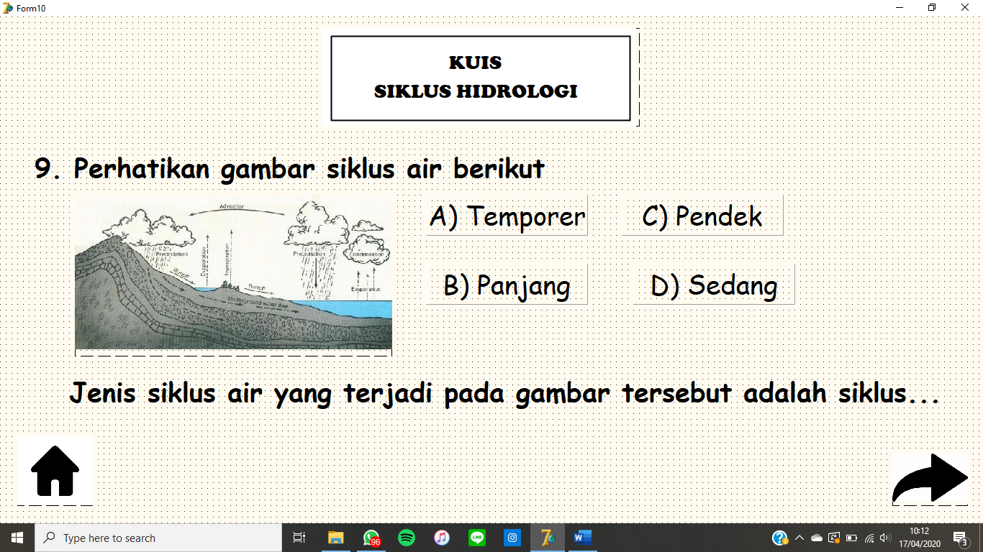

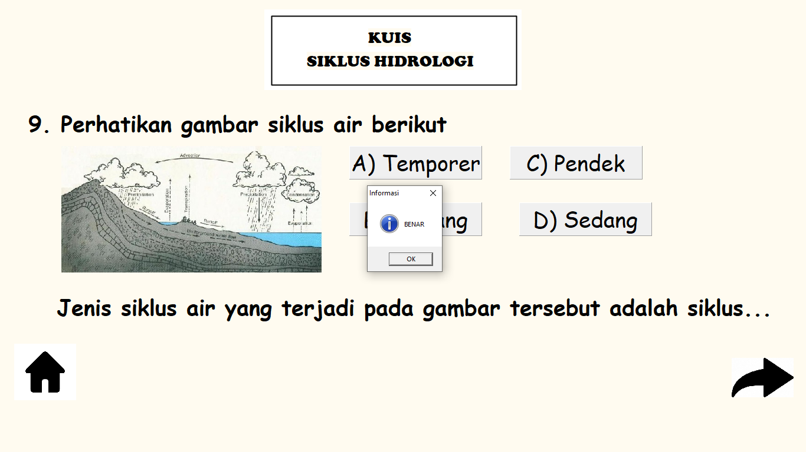

{ Public declarations }

end;

var

Form10: TForm10;

implementation

uses Unit1, Unit11;

{$R *.dfm}

procedure TForm10.Image2Click(Sender: TObject);

begin

form10.Hide;

form1.show;

end;

procedure TForm10.Image3Click(Sender: TObject);

begin

form10.Hide;

form11.show;

end;

procedure TForm10.Panel4Click(Sender: TObject);

begin

Application.MessageBox('BENAR','Informasi',MB_OK or MB_ICONINFORMATION);

end;

procedure TForm10.Panel3Click(Sender: TObject);

begin

Application.MessageBox('SALAH','Informasi',MB_OK or MB_ICONINFORMATION);

end;

procedure TForm10.Panel2Click(Sender: TObject);

begin

Application.MessageBox('SALAH','Informasi',MB_OK or MB_ICONINFORMATION);

end;

procedure TForm10.Panel1Click(Sender: TObject);

var

Form12: TForm12;

implementation

uses Unit1, Unit13;

{$R *.dfm}

procedure TForm12.Image2Click(Sender: TObject);

begin

form12.Hide;

form1.show;

end;

procedure TForm12.Image3Click(Sender: TObject);

begin

form12.Hide;

form13.show;

end;

procedure TForm12.RadioButton1Click(Sender: TObject);

begin

Application.MessageBox('JAWABAN SALAH','Informasi',MB_OK or MB_ICONINFORMATION);

end;

procedure TForm12.RadioButton2Click(Sender: TObject);

begin

Application.MessageBox('JAWABAN BENAR','Informasi',MB_OK or MB_ICONINFORMATION);

end;

procedure TForm12.RadioButton3Click(Sender: TObject);

begin

Application.MessageBox('JAWABAN SALAH','Informasi',MB_OK or MB_ICONINFORMATION);

end;

procedure TForm12.RadioButton4Click(Sender: TObject);

begin

Application.MessageBox('MAAF ANDA SALAH','informasi',MB_OK);

end;

procedure TForm16.CheckBox4Click(Sender: TObject);

begin

Application.MessageBox('MAAF ANDA SALAH','informasi',MB_OK);

end;

end.

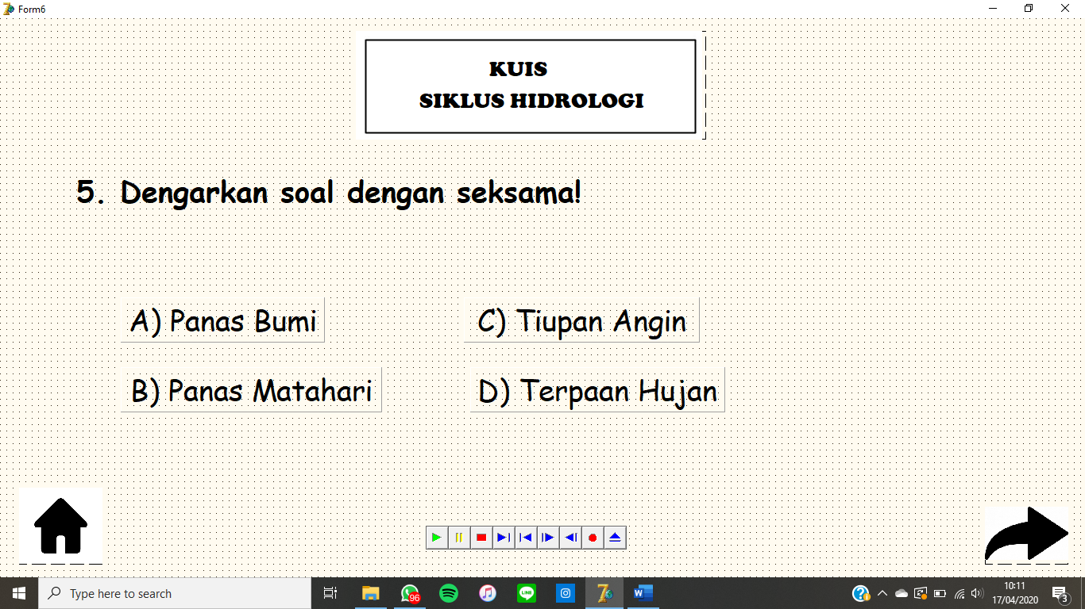

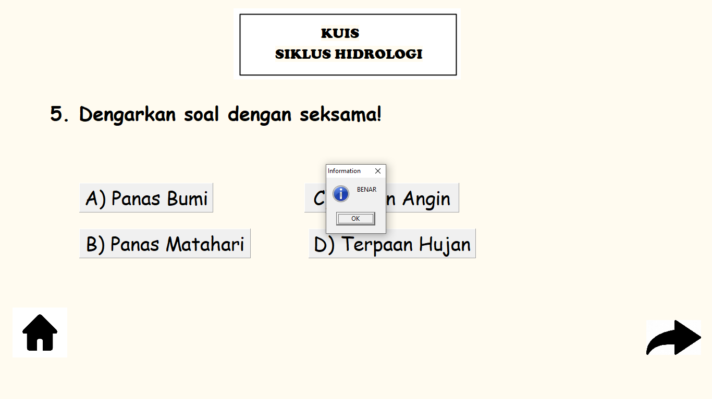

unit Unit6;

interface

uses

Windows, Messages, SysUtils, Variants, Classes, Graphics, Controls, Forms,

Dialogs, StdCtrls, jpeg, ExtCtrls, MPlayer;

type

TForm6 = class(TForm)

Image1: TImage;

Image2: TImage;

Image3: TImage;

Label1: TLabel;

Label2: TLabel;

Label3: TLabel;

Panel1: TPanel;

Panel2: TPanel;

Panel3: TPanel;

Panel4: TPanel;

mp7: TMediaPlayer;

procedure Image2Click(Sender: TObject);

procedure Image3Click(Sender: TObject);

procedure Button2Click(Sender: TObject);

procedure Button1Click(Sender: TObject);

procedure Button3Click(Sender: TObject);

procedure Button4Click(Sender: TObject);

procedure Panel1Click(Sender: TObject);

procedure Panel3Click(Sender: TObject);

procedure Panel4Click(Sender: TObject);

procedure Panel2Click(Sender: TObject);

procedure Label3Click(Sender: TObject);

private

{ Private declarations }

public

{ Public declarations }

end;

var

Form6: TForm6;

implementation

uses Unit1, Unit7;

{$R *.dfm}

procedure TForm6.Image2Click(Sender: TObject);

begin

form6.Hide;

form1.show;

end;

procedure TForm6.Image3Click(Sender: TObject);

begin

mp7.filename:='ftujuh.mp3';

mp7.Open;

mp7.play;

form6.Hide;

form7.show;

end;

procedure TForm6.Panel1Click(Sender: TObject);

begin

MessageDlg('SALAH',mtinformation,[mbOK],0);

end;

procedure TForm6.Panel3Click(Sender: TObject);

begin

MessageDlg('SALAH',mtinformation,[mbOK],0);

end;

procedure TForm6.Panel4Click(Sender: TObject);

begin

MessageDlg('SALAH',mtinformation,[mbOK],0);

end;

procedure TForm6.Panel2Click(Sender: TObject);

begin

MessageDlg('BENAR',mtinformation,[mbOK],0);

end;

procedure TForm6.Label3Click(Sender: TObject);

begin

end;

end.